We’re having an end of Spring Party on Thursday 19th May and all children are invited!
We would love everyone to stay for a school meal on this day.

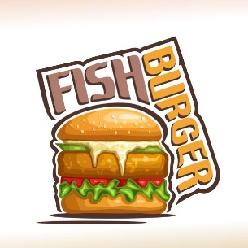
Menu
Fillet of fish in a Bun
Hot Dogs
Chips
Beans
Chocolate Cookie
or
Jelly and Ice-Cream

