Literacy Home Learning
Spring 1 Week 4
Monday
Starter- Full Stops-Read the sentences below and re-write them on a piece of paper correctly.
Objective- To identify the basic story plot using the beginning middle and end.
Can you identify the beginning middle and end of the story ‘The Gingerbread Man’
Challenge- Can you draw these pictures in the correct order and label them to identify if it is the beginning the middle or the end?

Tuesday
Starter- Adjectives
Objective- To sequence the story in the correct order.
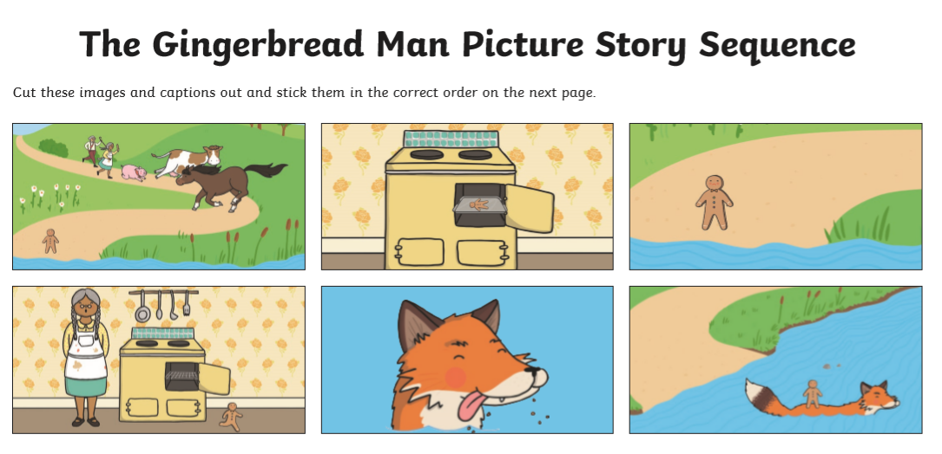
Are these pictures correct? Can you draw them in the correct order?
Challenge-
Here is a picture of a giant. There are adjectives written around him. Draw a picture of your favourite character and write as many adjectives as you can.

Wednesday
Starter- Question Marks

Objective- To compare characters in a variety of traditional tales.
- Can you identify these characters?
- What story do they belong to?
- Which characters are good?
- Which characters are bad?
- Pick two characters, draw them, write which story they are from and if you think the character is good or bad why.
Challenge- Can you write a list of questions you would like to ask one of the characters?

Here is an example. These questions are for Little Red Riding Hood
.
- Why did you not listen to your grown up?
- How did you know that it wasn’t Granny in bed?
- Did you ever see the wolf again?
- Do you think your mum will let you walk to Granny’s house on your own again?

- Remember to use your question words to help you. What, Where, Who, When, How and Do.

Thursday
Starter- Putting words together to create a sentence.

Objective- To capture language ideas to use during the writing phase.
“Oh Granny what big _____ you have”

“Fee Fi Fo Fum I smell the blood of an Englishman!”
Can you remember what The Gingerbread Man says? Can you draw a picture of him and write his repeated phrase? Here is a clue….”Run, Run as…
Challenge- Can you think of any other repeated phrases from traditional tales?
What does the Big Bad Wolf say in the story The Three Little Pigs? Here are some more traditional tales you can read.
Hansel and Gretal
The Three Billy Goats Gruff
Goldilocks and The Three Bears
The Little Red Hen

Friday
Starter- Revisit our phonic digraphs from this week.
ay,ou,ie,ea,oy and ir.
https://www.phonicsplay.co.uk/resources/phase/5/buried-treasure
Objective- Spelling, Grammar and Punctuation
Challenge- Can you read these words and say if they are real words or nonsense words.

