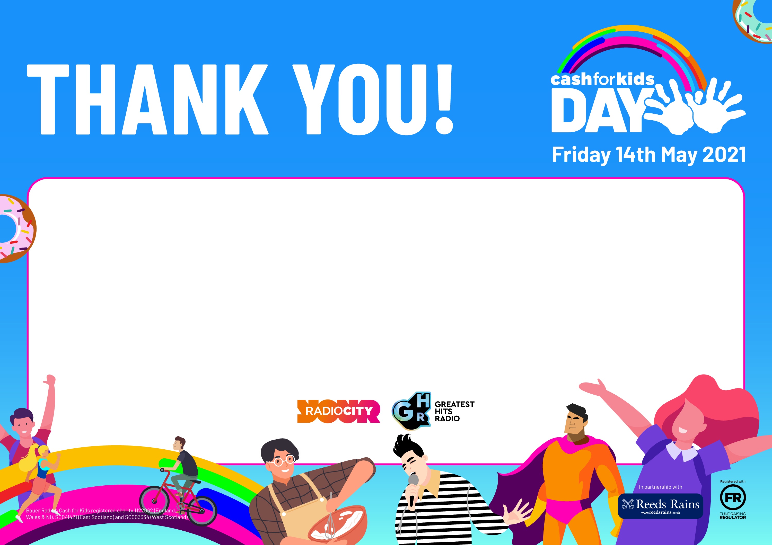

**St Cecilia’s Catholic Infant School**

**You raised an amazing £200 taking part in Cash for Kids Day 2021**

**We are extremely grateful for your support and on behalf of the children and families we help, we would like to say a huge THANK YOU.**

**Thank you so much**