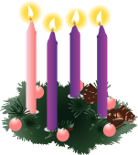
Advent Service
On Friday 1st December, the whole school were joined by Peter, the Parish trainee Priest for our school Advent Service and the blessing of our Advent wreaths. This special service was a wonderful start to our journey through Advent together.
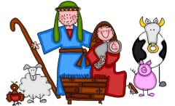
Thank you to all who then attended our weekly Advent Services in classes. The children really enjoy sharing these special times with their families and love to show off their singing skills and knowledge about this special time of year.
Christmas Performances
Well done to all our children from Nursery to Year 2 for their dazzling Christmas Performances. They enjoyed all aspects of this, from being on stage, playing musical instruments, singing new songs, to the rapturous applause from our great audiences.
A big ‘Thank You’ to all involved!
Christmas Dinner
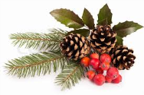
On Thursday 7th December our children enjoyed a Christmas lunch. The tables were decorated and Christmas music was playing. The children and staffed enjoyed this special lunch and a big ‘Thank You’ to Mrs. Hives and all the kitchen staff for providing a fabulous feast.
Christmas Table Decorations
A big thank you to Don Billington, our award winning gardener, for working so hard with the children to produce their Christmas table decorations. We’re sure they will be a beautiful festive centrepiece on your Christmas tables!
Christmas Photographs
We hope you are pleased with the festive class photographs of your children dressed in their costumes.
Please ensure photographs are paid for before the end of term.

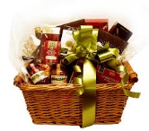
Christmas Hampers
Once again, a huge thank you to Cardinal Heenan for their donation of five Christmas hampers for our school. The lucky winners from our free raffle in each year group have been informed. We’re sure they will enjoy the Christmas goodies over the festive season!
PASCINS
A HUGE thank you to our PASCINS team for providing so many Christmas treats for our children, their dedication and hard work is always in evidence.
The children were so excited to see Father Christmas in our grotto and receive their chocolate reindeer.
Also, as part of our Christmas celebrations all children will be enjoying a Christmas party in their individual classes on Wednesday 20th December.
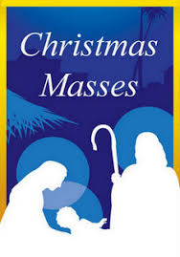
Children may wear their own clothes on this day and also the last day Thursday 21st December.
Christmas Mass Times
6:30pm – Christmas Eve Family Mass at St. Matthew’s
10:00pm – Midnight Mass at St. Cecilia’s
9:00am – Christmas Day at St. Matthew’s
10:30am – Christmas Day at St. Cecilia’s
Christmas Holidays
We finish school on Thursday 21st December at 1:30pm and return to school on Monday 8th January 2018.

We wish you all a very Merry Christmas and a happy and healthy New Year.
